Srilasya Garigipaty

DATA 1204 Statistical and Predictive Modeling

Assignment #1 Distribution Analysis

Student ID 100822953

**R-Script:**

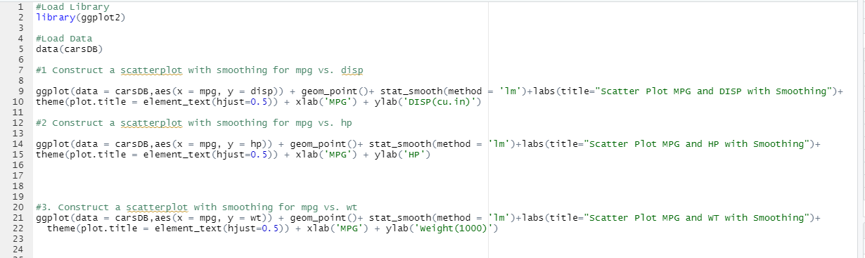

**Graphs:**

1.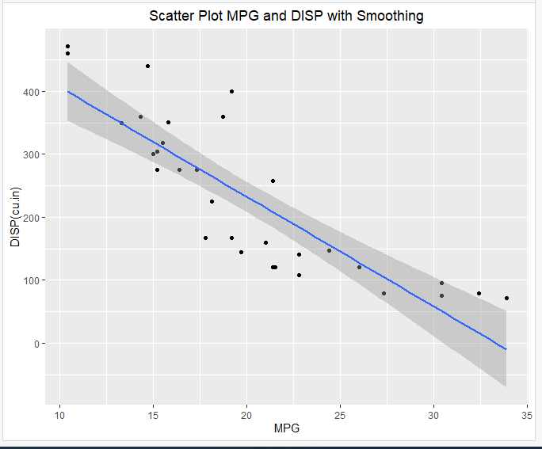

a. For the first scatterplot of mpg vs. displ, It can be concluded that as the displacement decreases, mpg increases.

b. For the first scatterplot of mpg vs displacement, it can be seen that there are anomalies in the range of displacement around 50 to 470 cubic inches. The maximum disp around 470 cubic inches at around 10 mpg, and the minimum disp around 70 cubic inches is around 33 mpg.

2. 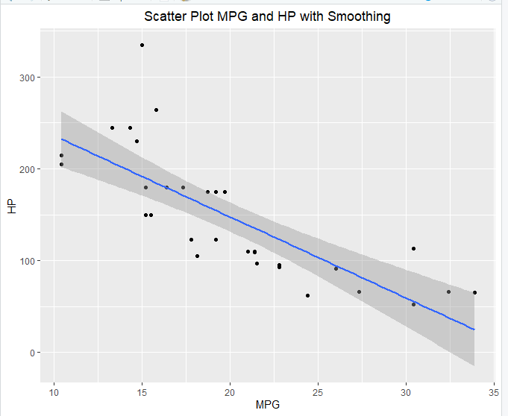

a. For the second scatterplot of mpg vs. hp, It can be concluded that as the mpg increases, hp decreases.

b. For the second scatterplot of mpg vs hp, it can be seen that there are anomalies in the range of 50 to 350 hp. The maximum HP around 340 occurs at 15 mpg and the minimum HP around 50 occurs around 30 mpg.

3. 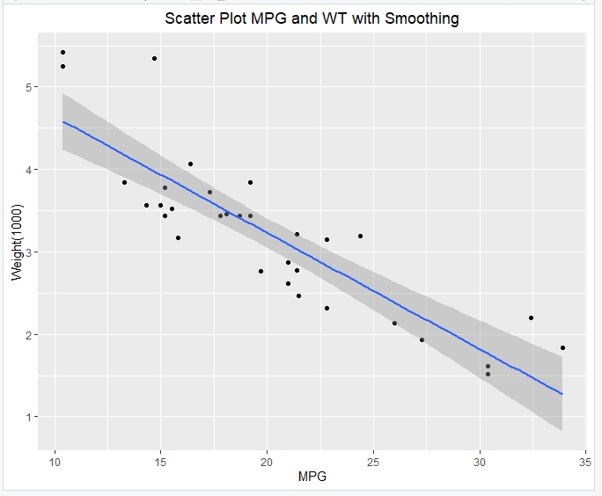

1. For the third scatterplot of mpg vs wt, It can be concluded that as weight decreases, the mpg increases.
2. For the third scatterplt of mpg vs weight(1000), it can be seen that there are anomalies in the range of weights 1500 lb to 5500 lbs. The maximum weight around 5500 lbs occurs around 10 mpg, and the minimum weight around 1500 lbs occurs around 30 mpg.